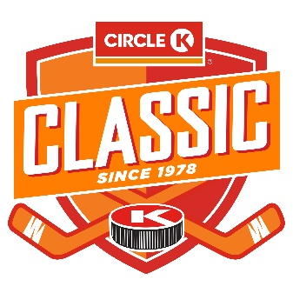
THE 45th ANNUAL CIRCLE K CLASSIC TOURNAMENT
CALGARY, ALBERTA, CANADA

THE WORLD INVITATIONAL CHAMPIONSHIP OF U18 “AAA” HOCKEY

MALE TEAM APPLICATION FORM
Tournament Dates: December 27th, 2023 to January 1st, 2024

Team Name
State or Provincial Branch
League Team Participates in
League Website
Name of League President |  | Email
Primary Phone |  | Secondary Phone
Team Manager |  | Email
Primary Phone |  | Secondary Phone
Head Coach Name |  | Email
Primary Phone |  | Secondary Phone
Mailing Address

Eligibility:
- Registered Governing Body Regulations:
  - Hockey Canada: Competing Teams must comply with Hockey Canada U18 Age Category Regulations
  - USA Hockey: Competing Teams must comply with ’18 & Under Midget’ (Male) or ’19 & Under Midget’ (Female) Youth/Junior Age Classifications of the USA Hockey Guide Book.
  - International Ice Hockey Federation: Competing Teams must comply with IIHF Ice Hockey Statutes and Bylaws defining ‘U18 - Gender, Age, Underage’ ****some exceptions or variations may apply.
- All North American teams are eligible who qualify for an age category National Championship.

Proof of Eligibility:
State, Provincial, or National governing body official roster document must be presented to the Tournament Committee prior to competition.

Expression of Interest:
We invite you to please submit this form as an expression of interest by scanning a completed form and returning it to ckcgm@hockeycalgary.com

Note: Teams will be notified by November 15, 2023 if they have qualified for the tournament. Registration fees will be due by Dec 1st via online registration through our website.

Signature of Team Official: _
Date:

Email Inquiries: ckcgm@hockeycalgary.com

